**IFT 466 Advanced Computer Networks**

**Lab 7  
EIGRP – Routing Distribution**

After you complete each step, put a ‘√’ or ‘x’ in the completed box

Routing redistribution is a process that allows a network to use a routing protocol to dynamically route traffic based on information learned from a different routing protocol

**Objective**Configure dynamic routing protocol between EIGRP and OSPF.

1. Setup the following topology in Packet Tracer

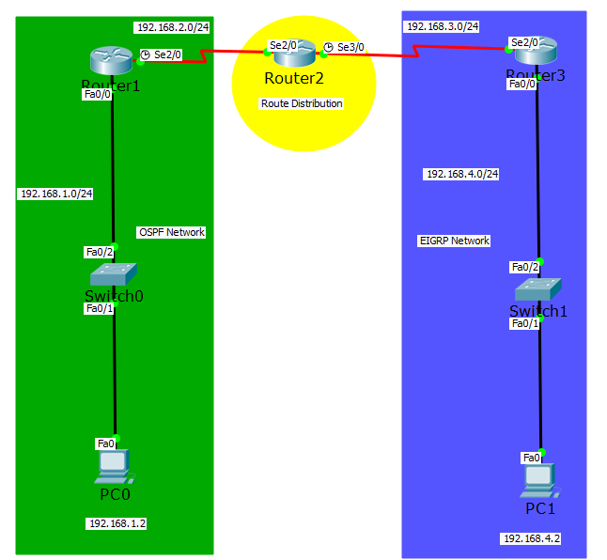



✓

1. Configure the PCs and routers with IP configuration details



✓

**Question**  
Can you ping PC1 from PC0?

NO

1. Now we will configure R1 with OSPF

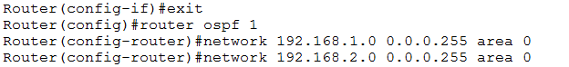

 ✓

1. Now configure R3 with EIGRP

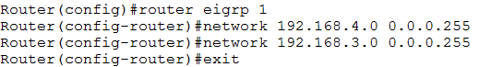

 ✓

1. Now configure R2 with OSPF & EIGRP

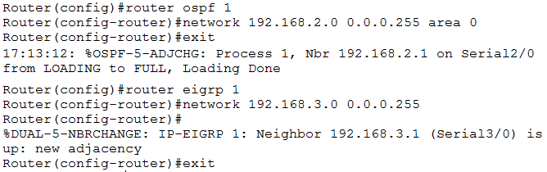



✓

1. Now we will configure the redistribute OSPF into EIGRP and redistribute EIGRP into OSPF on R2

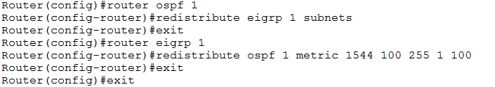



✓

1. Now ping PC1 from PC0. Do you get a successful ping?

 ✓

If not, then troubleshoot to find out why.

1. Run the show run command on R2 to see the redistributions







